**BLACKBUCKS INTERNSHIP REPORT**

**Hosting a PRIME CARE(Baby care center) static website using EC2 Instances, and Load balancer .**

SUBMITTED BY:

AINAVILLI SIVA TEJA GOUD(21B91A5704) CHILLIMUNTHA PAVAN KUMAR(21B91A5709)

**UNDER THE GUIDANCE OF MR. GURU SANTHOSH SEENIVASAN**

**Blackbuck Engineers Pvt.Ltd Road No 36,Jubilee Hills,Hyderabad**

**BLACKBUCK INTERNSHIP WORK**

**Team members:**

* AINAVILLI SIVA TEJA GOUD(21B91A5704)
* CHILLIMUNTHA PAVAN KUMAR(21B91A5709)

**Title:**

Hosting a PRIME CARE(Baby care center) static website using EC2 Instances in two different zones,and creating a Load Balancer in the specified region and balance traffic between two instances and verifying the load balancer DNS on the browser.

**Abstract:**

The "Prime Care" project involves hosting a static website for a baby care center using Amazon EC2 instances in two different availability zones (AZs) to ensure high availability and fault tolerance. Additionally, a load balancer will be set up in the specified region to efficiently distribute incoming web traffic between the two instances, providing a seamless and responsive user experience. The load balancer will be tested by verifying its DNS in a web browser.

The successful completion of this project will showcase the ability to leverage AWS services for web hosting, enhance the understanding of load balancing concepts, and demonstrate proficiency in deploying scalable and reliable static websites using Amazon EC2 and load balancers.

Table of Contents

Cloudcomputing 1

Cloud Computing Services 1

IaaS (Infrastructure-as-a-Service) 1

PaaS (Platform-as-a-service) 2

SaaS (Software-as-a-Service) 2

Cloud Service Providers 3

Amazon Web Services 3

Why AWS? 4

List of AWS Services 5

Amazon EC2 6

Amazon RDS 7

Amazon VPC 8

Amazon S3 9

Amazon IAM 10

AWS Lambda 12

AWS Cloud9 13

AWS Elastic BeanStalk 14

AWS CodeCommit 15

Amazon CloudWatch 17

Amazon EBS (Elastic Block Store) 18

Amazon Aurora 20

AWS Autoscaling 21

Create an IAM user with EC2 full access and Cloud front full access 23

IAM Service 23

IAM User 23

Creating IAM User 23

Launch an EC2 instance in two different availability zones and Configure web server in the instance 29

EC2 Instance 29

Launching EC2 Instances 29

Web Server 34

Configuring web Server 34

Hosting Website 36

Access Your Website 37

Create a Load balancer in the specified region 39

and balance traffic between two instances 39

Load balancer 39

Target Group 39

Creating a Target Group 39

Verifying the load balancer DNS on the browser 48

Verifying the Load balancer DNS 48

Create a cloud front distribution and 50

push the load balancer DNS to the cloud front 50

Cloud front 50

**Steps to create cloud front distribution: 51-55**

**Services Used:**

* **Identity Access Management(IAM)**
* **Elastic Compute cloud(EC2)**
* **Cloud Front**

**Architecture:**

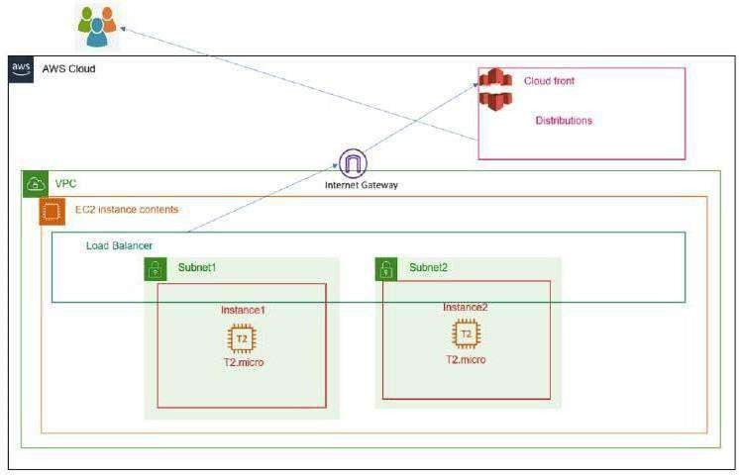

**Description:**

The architecture of a web service load balancer is designed to efficiently distribute incoming network traffic across multiple backend servers or instances hosting the web service. This architecture aims to enhance performance, scalability, and availability, ensuring that the web service can handle a large number of concurrent users and traffic spikes without overloading any single server. At the forefront of the architecture is the frontend load balancer. It acts as the entry point for incoming client requests. Clients send their requests to the load balancer, which then determines the appropriate backend server to handle the request. Behind the frontend load balancer, there are multiple backend servers or instances. These are the actual servers that host the web service and process client requests.

##### Cloud computing:

Cloud computing is on-demand access, via the internet, to computing resources— applications, servers (physical servers and virtual servers), data storage, development tools, networking capabilities, and more— hosted at a remote data center managed by a cloud services provider (or CSP). The CSP makes these resources available for a monthly subscription fee or bills them according to usage

Compared to traditional on-premises IT, and depending on the cloud services you select, cloud computing helps do the following:

* **Lower IT costs:** Cloud lets you offload some or most of the costs and effort of purchasing, installing, configuring, and managing your own on-premises infrastructure.
* **Improve agility and Ɵme-to-value:** With cloud, your organization can start using enterprise applications in minutes, instead of waiting weeks or months for IT to respond to a request, purchase and configure supporting hardware, and install software. Cloud also lets you empower certain users—specifically developers and data scientists.
* **Scale more easily and cost-effecƟvely:** Cloud provides elasticity—instead of purchasing excess capacity that sits unused during slow periods, you can scale capacity up and down in response to spikes and dips in traffic. You can also take advantage of your cloud provider’s global network to spread your applications closer to users around the world.

The term ‘cloud computing’ also refers to the technology that makes cloud work. This includes some form of virtualized IT infrastructure—servers, operating system software, networking, and other infrastructure that’s abstracted, using special software, so that it can be pooled and divided irrespective of physical hardware boundaries. For example, a single hardware server can be divided into multiple virtual servers.

Cloud Computing Services:

* IaaS (Infrastructure-as-a-Service)
* PaaS (Platform-as-a-Service)
* SaaS (Software-as-a-service)

are the three most common models of cloud services, andit’s not uncommon for an organization to use all three.

**IaaS (Infrastructure-as-a-Service)**

IaaS provides on-demand access to fundamental computing resources—physical and virtual servers, networking, and storage—over the internet on a pay-as-you-go basis. IaaS enables end users to scale and shrink resources on an as-needed basis, reducing the need for high, up-front capital expenditures or unnecessary on-premises or ‘owned’ infrastructure and for overbuying resources to accommodate periodic spikes in usage.

In contrast to SaaS and PaaS (and even newer PaaS computing models such as containers and serverless), IaaS provides the users with the lowest-level control of computing resources in the cloud.

IaaS was the most popular cloud computing model when it emerged in the early 2010s. While it remains the cloud model for many types of workloads, use of SaaS and PaaS is growing at a much faster rate.

**PaaS (Platform-as-a-service)**

PaaS provides software developers with on-demand platform—hardware, complete software stack, infrastructure, and even development tools—for running, developing, and managing applications without the cost, complexity, and inflexibility of maintaining that platform on- premises.

With PaaS, the cloud provider hosts everything—servers, networks, storage, operating system software, middleware, databases—at their data center.

Today, PaaS is often built around containers, a virtualized compute model one step removed from virtual servers. containers virtualize the operating system, enabling developers to package the application with only the operating system services it needs to run on any platform, without modification and without need for middleware.

**SaaS (Software-as-a-Service)**

SaaS—also known as cloud-based software or cloud applications—is application software that’s hosted in the cloud, and thatuser’s access via a web browser, a dedicated desktop client, or an API that integrates with a desktop or mobile operating system. In most cases, SaaS users pay a monthly or annual subscription fee; some may offer ‘pay-as-you-go’ pricing based on your actual usage.

In addition to the cost savings, time-to-value, and scalability benefits of cloud, SaaS offers the following:

* **Automatic upgrades:** With SaaS, users take advantage of new features as soon as the provider adds them, without having to orchestrate an on-premises upgrade.
* **Protection from data loss**: Because SaaS stores application data in the cloud with the application, users don’t lose data if their device crashes or breaks. SaaS is the primary delivery model for most commercial software today—there are hundreds of thousands of SaaS solutions available, from the most focused industry and departmental applications to

powerful enterprise software database and AI (artificial intelligence) software

##### Cloud Service Providers:

* + Amazon Web Services
  + Microsoft Azure
  + Google Cloud Platform
  + Oracle
  + IBM cloud
  + Salesforce

##### Amazon Web Services:

Amazon Web Services, Inc. (AWS) is a subsidiary of Amazon that provides on-demand cloud computing platforms and APIs to individuals, companies, and governments, on a metered, pay- as- you-go basis. Oftentimes, clients will use this in combination with autoscaling (a process that allows a client to use more computing in times of high application usage, and then scale down to reduce costs when there is less traffic). These cloud computing web services provide various services related to networking, computing, storage, middleware, IoT and other processing capacity, as well as software tools via AWS server farms. This frees clients from managing, scaling, and patching hardware, and operating systems

One of the foundational services is Amazon Elastic Compute Cloud (EC2), which allows users to have at their disposal a virtual cluster of computers, with extremely high availability, which can be interacted with over the internet via REST APIs, a CLI or the AWS console. AWS's virtual computers emulate most of the attributes of a real computer, including hardware central processing units (CPUs) and graphics processing units (GPUs) for processing; local/RAM memory; hard disk /SSD storage; a choice of operating systems; networking; and pre-loaded application software such as web servers, databases, and customer relationship management (CRM).

AWS services are delivered to customers via a network of AWS server farms located throughout the world. Fees are based on a combination of usage (known as a "Pay-as-you-go" model), hardware, operating system, software, or networking features chosen by the subscriber required availability, redundancy, security, and service options. Subscribers can pay for a single virtual AWS computer, a dedicated physical computer, or clusters of either.

Amazon provides select portions of security for subscribers (e.g., physical security of the data centers) while other aspects of security are the responsibility of the subscriber (e.g., account management, vulnerability scanning, patching). AWS operates for many global geographical regions including seven in North America.

Amazon markets AWS to subscribers as a way of obtaining large-scale computing capacity more quickly and cheaply than building an actual physical server farm. All services are billed based on usage, but each service measures usage in varying ways.

##### Why AWS?

* **Easy to use:**

AWS is designed to allow application providers, ISVs, and vendors to host your applications quickly and securely – whether an existing application or a new SaaSbased application. You can use the AWS Management Console or well- documented web services APIs toaccess AWS’s application hosting platform.

* **Flexible:**

AWS enables you to select the operating system, programming language, web application platform, database, and other services you need. With AWS, you receive a virtual environment that lets you load the software and services your application requires. This eases the migration process for existing applications while preserving options for building new solutions.

* **Cost-effective**:

You pay only for the compute power, storage, and other resources you use, with no long-term contracts or up-front commitments. For more information on comparing the costs of other hosting alternatives with AWS, see the AWS Economics Center.

* **Reliable:**

With AWS, you take advantage of a scalable, reliable, and secure global computing infrastructure, the virtual backbone of Amazon.com’s multi-billion- dollar online business that has been honed for over a decade.

* **Scalable and High performance:**

Using AWS tools, Auto Scaling, and Elastic Load Balancing, your application can scale up or down based ondemand. Backed by Amazon’s massive infrastructure, you have access to compute and storage resources when you need them.

* **Secure:**

Using AWS tools, Auto Scaling, and Elastic Load Balancing, your application can scale up or down based ondemand. Backed by Amazon’s massive infrastructure, you have access to compute and storage resources when you need them.

##### List of AWS Services:

Amazon, the preeminent cloud vendor, broke new ground by establishing the first cloud computing service, Amazon EC2, in 2008. AWS offers more solutions and features than any other provider and has free tiers with access to the AWS Console, where users can centrally control their ministrations. Designed around ease-of-use for various skill sets, AWS is tailored for those unaccustomed to software development utilities. Web applications can be deployed in minutes with AWS facilities, without provisioning servers or writing additional code.

* Amazon EC2 (Elastic Compute Cloud)
* Amazon RDS (Relational Database Services)
* Amazon S3 (Simple Storage Service)
* Amazon Lambda
* Amazon Cognito
* Amazon Glacier
* Amazon SNS (Simple Notification Service)
* Amazon VPC (Virtual Private Cloud)
* Amazon Lightsail
* Amazon CloudWatch
* Amazon Cloud9
* Amazon Elastic Beanstalk
* Amazon CodeCommit
* Amazon IAM (Identity and Access Management)
* Amazon Inspector
* Amazon Kinesis
* Amazon Dynamo DB
* Amazon Codecatalyst
* Amazon Kinesis
* AWS Athena
* AWS Amplify
* AWS Quicksight
* AWS Cloudformation

## Amazon EC2:

Amazon Elastic Compute Cloud (EC2) is a part of Amazon.com's cloud- computing platform, Amazon Web Services (AWS), that allows users to rent virtual computers on which to run their own computer applications. EC2 encourages scalable deployment of applications by providing a web service through which a user can boot an Amazon Machine Image (AMI) to configure a virtual machine, which Amazon calls an "instance", containing any software desired. A user can create, launch, and terminate server- instances as needed, paying by the second for active servers – hence the term "elastic". EC2 provides users with control over the geographical location of instances that allows for latency optimization and high levels of redundancy. In November 2010, Amazon switched its own retail website platform to EC2 and AWS.

Amazon announced a limited public beta test of EC2 on August 25, 2006, offering access on a first- come, first-served basis. Amazon added two new instance types (Large and Extra-Large) on October 16, 2007. On May 29, 2008, two more types were added, High- CPU Medium and High- CPU Extra Large. There were twelve types of instances available.

Amazon added three new features on March 27, 2008, static IP addresses, availability zones, and user selectable kernels. On August 20, 2008, Amazon added Elastic Block Store (EBS) This provides persistent storage, a feature that had been lacking since the service was introduced.

**Instance types:**

Initially, EC2 used Xen virtualization exclusively. However, on November 6, 2017, Amazon announced the new C5 family of instances that were based on a custom architecture around the KVM hypervisor, called Nitro. Each virtual machine, called an "instance", functions as a virtual private server. Amazon sizes instances based on "Elastic Compute Units". The performance of otherwise identical virtual machines may vary. On November 28, 2017, AWS announced a bare- metal instance type offering marking a remarkable departure from exclusively offering virtualized instance types.

As of January 2019, the following instance types were offered:

* General Purpose: A1, T3, T2, M5, M5a, M4, T3a
* Compute Optimized: C5, C5n, C4
* Memory Optimized: R5, R5a, R4, X1e, X1, High Memory, z1d
* Accelerated Computing: P3, P2, G3, F1
* Storage Optimized: H1, I3, D2

As of April 2018, the following payment methods by instance were offered:

* On-demand: pay by the hour without commitment.
* Reserved: rent instances with one-time payment receiving discounts on the hourly charge.
* Spot: bid-based service runs the jobs only if the spot price is below the bid specified by bidder. The spot price is claimed to be supply-demand based, however a 2011 study concluded that the price was generally not set to clear the market but was dominated by an undisclosed reserve price

##### Amazon RDS:

**Amazon Relational Database Service (or Amazon RDS)** is a distributed relational database service by Amazon Web Services (AWS). It is a web service running "in the cloud" designed to simplify the setup, operation, and scaling of a relational database for use in applications. Administration processes like patching the database software, backing up databases and enabling point-in-time recovery are managed automatically. Scaling storage and compute resources can be performed by a single API call to the AWS control plane on-demand. AWS does not offer an SSH connection to the underlying virtual machine as part of the managed service.

**Multiple Availability Zone (AZ) Deployment**

In May 2010 Amazon announced Multi-Availability Zone deployment support. Amazon RDS MultiAvailability Zone (AZ) allows users to automatically provision and maintain a synchronous physical or logical "standby" replica, depending on database engine, in a different Availability Zone (independent infrastructure in a physically separate location). Multi-AZ database instance can be developed at creation time or modified to run as a multi-AZ deployment later. Multi-AZ deployments aim to provide enhanced availability and data durability for MySQL, MariaDB, Oracle, PostgreSQL and SQL Server instances and are targeted for production environments. In the event of planned database maintenance or unplanned service disruption, Amazon RDS automatically fails over to the up-to-date standby, allowing database operations to resume without administrative intervention.

Multi-AZ RDS instances are optional and have a cost associated with them. When creating a RDS instance, the user is asked if they would like to use a multi-AZ RDS instance. In Multi- AZ RDS deployments backups are done in the standby instance so I/O activity is not suspended any time, but users may experience elevated latencies for a few minutes during backups.

**Read replicas.**

Read replicas allow different use cases such as scale in for read-heavy database workloads. There are up to five replicas available for MySQL, MariaDB, and PostgreSQL. Instances use the native, asynchronous replication functionality of their respective database engines. They have no backups configured by default and are accessible and can be used for read scaling. MySQL and MariaDB read replicas and can be made writeable again since October 2012; PostgreSQL read replicas do not support it. Replicas are done at database instance level and do not support replication at database or table level.

**Performance metrics and monitoring**

Performance metrics for Amazon RDS are available from the AWS Management Console or the Amazon CloudWatch API. In December 2015, Amazon announced an optional enhanced monitoring feature that provides an expanded set of metrics for the MySQL, MariaDB, and Aurora database engines.

##### Amazon VPC:

Amazon Virtual Private Cloud (VPC) is a commercial cloud computing service that provides a virtual private cloud, by provisioning a logically isolated section of Amazon Web Services (AWS) Cloud. Enterprise customers are able to access the Amazon Elastic Compute Cloud (EC2) over an IPsec based virtual private network. Unlike traditional EC2 instances which are allocated internal and external IP numbers by Amazon, the customer can assign IP numbers of their choosing from one or more subnets.

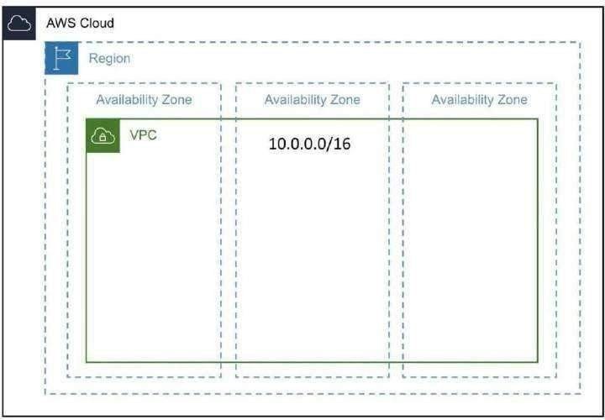

Fig: AWS VPC Architecture

Amazon Web Services launched Amazon Virtual Private Cloud on 26 August 2009, which allows the Amazon Elastic Compute Cloud service to be connected to legacy infrastructure over an IPsec VPN. In AWS, the basic VPC is free to use, with users being charged by usage for additional features.EC2 and RDS instances running in a VPC can also be purchased using Reserved Instances, however will have a limitation on resources being guaranteed[citation needed].

IBM Cloud launched IBM Cloud VPC on 4 June 2019, provides an ability to manage virtual machine- based compute, storage, and networking resources. Pricing for IBM Cloud Virtual Private Cloud is

applied separately for internet data transfer, virtual server instances, and block storage used within IBM Cloud VPC.

Google Cloud Platform resources can be provisioned, connected, and isolated in a virtual private cloud (VPC) across all GCP regions. With GCP, VPCs are global resources and subnets within that VPC are regional resources. This allows users to connect zones and regions without the use of additional networking complexity as all data travels, encrypted in transit and at rest, on Google's own global, private network. Identity management policies and security rules allow for private access to Google's storage, big data, and analytics managed services. VPCs on Google Cloud Platform leverage the security of Google's data centers.

##### Amazon S3:

Amazon S3 manages data with an object storage architecture which aims to provide scalability, high availability, and low latency with high durability. The basic storage units of Amazon S3 are objects which are organized into buckets. Each object is identified by a unique, user- assigned key. Buckets can be managed using the console provided by Amazon S3, programmatically with the AWS SDK, or the REST application programming interface.

Objects can be up to five terabytes in size. Requests are authorized using an access control list associated with each object bucket and support versioning which is disabled by default. Since buckets are typically the size of an entire file system mount in other systems, this access control scheme is very coarse-grained. In other words, unique access controls cannot be associated with individual files. [citation needed] Amazon S3 can be used to replace static web-hosting infrastructure with HTTP client-accessible objects, index document support and error document support.

The Amazon AWS authentication mechanism allows the creation of authenticated URLs, valid for a specified amount of time. Every item in a bucket can also be served as a BitTorrent feed. The Amazon S3 store can act as a seed host for a torrent and any BitTorrent client can retrieve the file. This can drastically reduce the bandwidth cost for the download of popular objects. A bucket can be configured to save HTTP log information to a sibling bucket; this can be used in data mining operations.

There are various User Mode File System (FUSE)–based file systems for Unix-like operating systems (for example, Linux) that can be used to mount an S3 bucket as a file system. The semantics of the Amazon S3 file system is not that of a POSIX file system, so the file system may not behave entirely as expected.

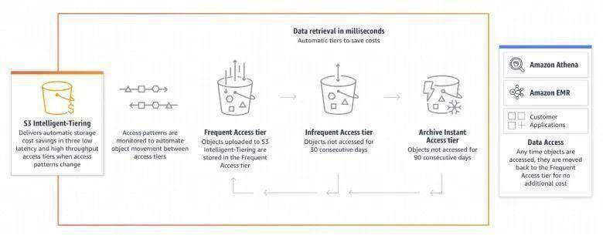

**Fig: AWS S3 Storage Classes**

##### Amazon IAM:

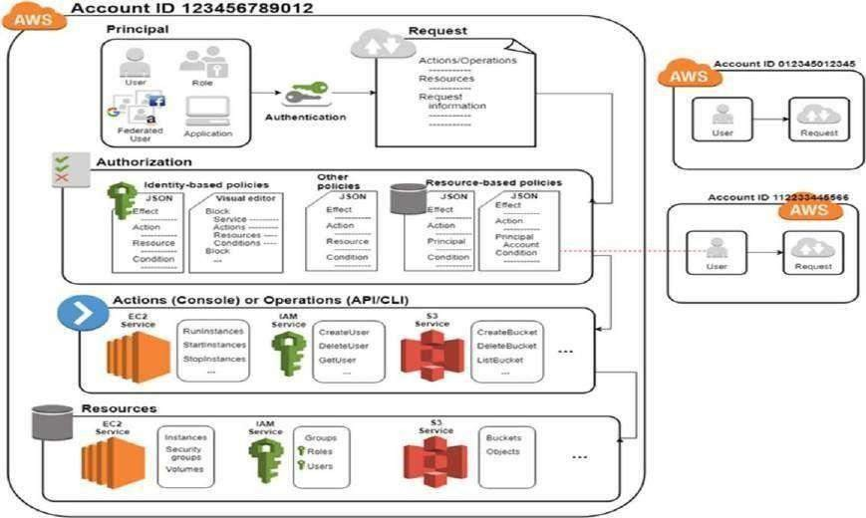IAM provides the infrastructure necessary to control authentication and authorization for your AWS account. The IAM infrastructure is illustrated by the following diagram.

Fig: AWS Identity and Access Management

First, a human user or an application uses their sign-in credentials to authenticate with AWS. Authentication is provided by matching the sign-in credentials to a principal (an IAM user, federated user, IAM role, or application) trusted by the AWS account.

Next, a request is made to grant the principal access to resources. Access is granted in response to an authorization request. For example, when you first sign into the console and are on the console home page, you are not accessing a specific service. When you select a service, the request for authorization is sent to that service and it looks to see if your identity is on the list of authorized users, what policies are being enforced to control the level of access granted, and any other policies that might be in effect. Authorization requests can be made by principals within your AWS account or from another AWS account that you trust.

Once authorized, the principal can take action or perform operations on resources in your AWS account. For example, the principal could launch a new Amazon Elastic Compute Cloud instance, modify IAM group membership, or delete Amazon Simple Storage Service buckets.

The previous illustration we used specific terminology to describe how to obtain access to resources. These IAM terms are commonly used when working with AWS:

IAM Resources

The user, group, role, policy, and identity provider objects that are stored in IAM. As with other AWS services, you can add, edit, and remove resources from IAM.

IAM Identities

The IAM resource objects that are used to identify and group. You can attach a policy to an IAM identity. These include users, groups, and roles.

IAM Entities

The IAM resource objects that AWS uses for authentication. These include IAM users and roles. Principals

A person or application that uses the AWS account root user, an IAM user, or an IAM role to sign in and make requests to AWS. Principals include federated users and assumed roles.

Human users

Also known as human identities; the people, administrators, developers, operators, and consumers of your applications.

Workload

A collection of resources and code that delivers business value, such as an application or backend process. Can include applications, operational tools, and components.

##### AWS Lambda:

AWS Lambda is a compute service that lets you run code without provisioning or managing servers.

Lambda runs your code on a high-availability compute infrastructure and performs all of the administration of the compute resources, including server and operating system maintenance, capacity provisioning and automatic scaling, and logging. With Lambda, all you need to do is supply your code in one of the language runtimes that Lambda supports.

You organize your code into Lambda functions. The Lambda service runs your function only when needed and scales automatically. You only pay for the compute time that you consume— there is no charge when your code is not running.

When using Lambda, you are responsible only for your code. Lambda manages the compute fleet that offers a balance of memory, CPU, network, and other resources to run your code. Because Lambda manages these resources, you cannot log in to compute instances or customize the operating system on provided runtimes.

Lambda performs operational and administrative activities on your behalf, including managing capacity, monitoring, and logging your Lambda functions.

If you do need to manage your compute resources, AWS has other compute services to consider, such as:

* AWS App Runner builds and deploys containerized web applications automatically, load balances traffic with encryption, scales to meet your traffic needs, and allows for the configuration of how services are accessed and communicate with other AWS applications in a private Amazon VPC.
* AWS Fargattie with Amazon ECS runs containers without having to provision, configure, or scale clusters of virtual machines.
* Amazon EC2 lets you customize operating system, network and security seƫtings, and the entire software stack. You are responsible for provisioning capacity, monitoring fleet health and performance, and using Availability Zones for fault tolerance.

You can use environment variables to adjust your function's behavior without updating code. An environment variable is a pair of strings that is stored in a function's version- specific configuration. The Lambda runtime makes environment variables available to your code and sets additional environment variables that contain information about the function and invocation request.

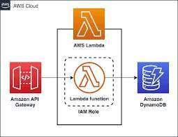

Fig: AWS lambda

##### AWS Cloud9:

AWS Cloud9 is an integrated development environment, or IDE.

The AWS Cloud9 IDE offers a rich code-editing experience with support for several programming languages and runtime debuggers, and a built-in terminal. It contains a collection of tools that you use to code, build, run, test, and debug software, and helps you release software to the cloud.

You access the AWS Cloud9 IDE through a web browser. You can configure the IDE to your preferences. You can switch color themes, bind shortcut keys, enable programming language- specific syntax coloring and code formatting, and more.

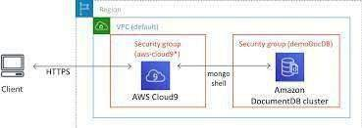

Fig: AWS Cloud9 Environments

**Environments and computing resources**

Behind the scenes, there are a couple of ways you can connect your environments to computing resources:

* You can instruct AWS Cloud9 to create an Amazon EC2 instance, and then connect the environment to that newly created EC2 instance. This type of setup is called an EC2 environment.
* You can instruct AWS Cloud9 to connect an environment to an existing cloud compute instance or to your own server. This type of setup is called an SSH environment.

EC2 environments and SSH environments have some similarities and some differences. If you're new to AWS Cloud9, we recommend that you use an EC2 environment because AWS Cloud9 takes care of much of the configuration for you. As you learn more about AWS Cloud9, and want to understand these similarities and differences better, see EC2 environments compared with SSH environments in AWS Cloud9.

##### AWS Elastic BeanStalk:

Amazon Web Services (AWS) comprises over one hundred services, each of which exposes an area of functionality. While the variety of services offers flexibility for how you want to manage your AWS infrastructure, it can be challenging to figure out which services to use and how to provision them.

With Elastic Beanstalk, you can quickly deploy and manage applications in the AWS Cloud without having to learn about the infrastructure that runs those applications. Elastic Beanstalk reduces management complexity without restricting choice or control. You simply upload your application, and Elastic Beanstalk automatically handles the details of capacity provisioning, load balancing, scaling, and application health monitoring.

Elastic Beanstalk supports applications developed in Go, Java, .NET, Node.js, PHP, Python, and Ruby. When you deploy your application, Elastic Beanstalk builds the selected supported platform version and provisions one or more AWS resources, such as Amazon EC2 instances, to run your application.

You can interact with Elastic Beanstalk by using the Elastic Beanstalk console, the AWS Command Line Interface (AWS CLI), or eb, a high-level CLI designed specifically for Elastic Beanstalk.

To learn more about how to deploy a sample web application using Elastic Beanstalk, see Getting Started with AWS: Deploying a Web App.

You can also perform most deployment tasks, such as changing the size of your fleet of Amazon EC2 instances or monitoring your application, directly from the Elastic Beanstalk web interface (console).

To use Elastic Beanstalk, you create an application, upload an application version in the form of an application source bundle (for example, a Java .war file) to Elastic Beanstalk, and then provide

some information about the application. Elastic Beanstalk automatically launches an environment and creates and configures the AWS resources needed to run your code. After your environment is launched, you can then manage your environment and deploy new application versions. The following diagram illustrates the workflow of Elastic Beanstalk.

AWS CodeCommit:

CodeCommit is a secure, highly scalable, managed source control service that hosts private Git repositories. CodeCommit eliminates the need for you to manage your own source control system or worry about scaling its infrastructure. You can use CodeCommit to store anything from code to binaries. It supports the standard functionality of Git, so it works seamlessly with your existing Git- based tools.

With CodeCommit, you can:

* **Benefit from a fully managed service hosted by AWS.** CodeCommit provides high service availability and durability and eliminates the administrative overhead of managing your own hardware and software. There is no hardware to provision and scale and no server software to install, configure, and update.
* **Store your code securely**. CodeCommit repositories are encrypted at rest as well as in transit.
* **Work collaboratively on code.** CodeCommit repositories support pull requests, where users can review and comment on each other's code changes before merging them to branches; noƟfications that automatically send emails to users about pull requests and comments; and more
* **Easily scale your version control projects**. CodeCommit repositories can scale up to meet your development needs. The service can handle repositories with large numbers of files or branches, large file sizes, and lengthy revision histories.
* **Store anything, anytime**. CodeCommit has no limit on the size of your repositories or on the file types you can store.
* **Integrate with other AWS and third-party services**. CodeCommit keeps your repositories close to your other production resources in the AWS Cloud, which helps increase the speed and frequency of your development lifecycle. It is integrated with IAM and can be used with other AWS services and in parallel with other repositories. For more information, see Product and service integrations with AWS CodeCommit.
* **Easily migrate files from other remote repositories**. You can migrate to CodeCommit from any Git- based repository.
* **Use the Git tools you already know.** CodeCommit supports Git commands as well as its own AWS CLI commands and APIs.

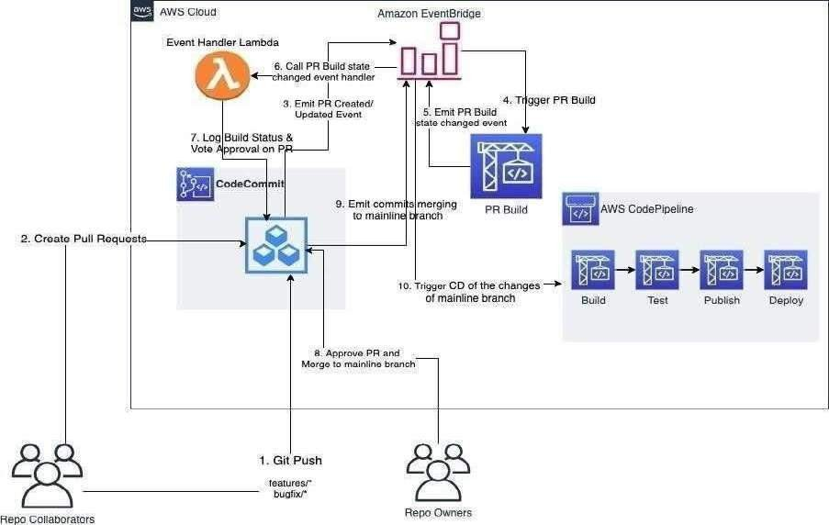

Fig: AWS Codecommit

## Amazon CloudWatch:

Amazon CloudWatch monitors your Amazon Web Services (AWS) resources and the applications you run on AWS in real time. You can use CloudWatch to collect and track metrics, which are variables you can measure for your resources and applications.

The CloudWatch home page automatically displays metrics about every AWS service you use. You can additionally create custom dashboards to display metrics about your custom applications and display custom collections of metrics that you choose.

You can create alarms that watch metrics and send notifications or automatically make changes to the resources you are monitoring when a threshold is breached. For example, you can monitor the CPU usage and disk reads and writes of your Amazon EC2 instances and then use that data to determine whether you should launch additional instances to handle increased load. You can also use this data to stop underused instances to save money.

With CloudWatch, you gain system-wide visibility into resource utilization, application performance, and operational health

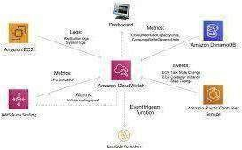

Fig: Amazon Cloud Watch

##### Amazon EBS (Elastic Block Store):

Amazon Elastic Block Store (Amazon EBS) provides block level storage volumes for use with EC2 instances. EBS volumes behave like raw, unformatted block devices. You can mount these volumes as devices on your instances. EBS volumes that are attached to an instance are exposed as storage volumes that persist independently from the life of the instance. You can create a file system on top of these volumes or use them in any way you would use a block device (such as a hard drive). You can dynamically change the configuration of a volume attached to an instance.

We recommend Amazon EBS for data that must be quickly accessible and requires long- term persistence. EBS volumes are particularly well-suited for use as the primary storage for file systems, databases, or for any applications that require fine granular updates and access to raw, unformatted, block-level storage. Amazon EBS is well suited to both database-style applications that rely on random reads and writes, and to throughput-intensive applications that perform long, continuous reads and writes.

With Amazon EBS, you pay only for what you use. For more information about Amazon EBS pricing, see the Projecting Costs Section of the Amazon Elastic Block Store page.

Features of Amazon EBS

* You create an EBS volume in a specific Availability Zone, and then attach it to an instance in that same Availability Zone. To make a volume available outside of the Availability Zone, you can create a snapshot and restore that snapshot to a new volume anywhere in that Region. You can copy snapshots to other Regions and then restore them to new volumes there, making it easier to leverage multiple AWS Regions for geographical expansion, data center migration, and disaster recovery.
* Amazon EBS provides the following volume types: General Purpose SSD, Provisioned IOPS SSD, Throughput Optimized HDD, and Cold HDD. For more information, see EBS volume types.

The following is a summary of performance and use cases for each volume type

* + General Purpose SSD volumes (gp2 and gp3) balance price and performance for a wide variety of transactional workloads. These volumes are ideal for use cases such as boot volumes, medium-size single instance databases, and development and test environments.
  + Provisioned IOPS SSD volumes (io1 and io2) are designed to meet the needs of I/O- intensive workloads that are sensitive to storage performance and consistency. They provide a consistent IOPS rate that you specify when you create the volume. This enables you to predictably scale to tens of thousands of IOPS per instance. Additionally, io2 volumes provide the highest levels of volume durability

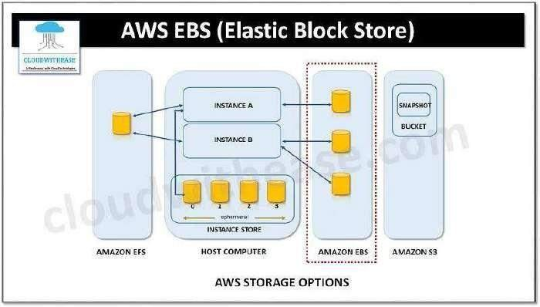

Fig: AWS EBS: Amazon Elastic Block Store

#### Create an IAM user with EC2 full access and Cloud front full access

###### IAM Service:

AWS Identity and Access Management (IAM) is a web service provided by Amazon Web Services (AWS) that enables you to securely manage access to AWS resources. IAM allows you to control who can use which resources and what actions they can perform on those resources. It helps you set up and manage user identities, groups, and permissions within your AWS account.

###### IAM USER:

IAM user is an identity that represents a person or an application that interacts with AWS services. IAM (Identity and Access Management) is the service within AWS that enables you to manage users, groups, and permissions to access and control AWS resources securely.

IAM users are used to control access to AWS services and resources without the need to share AWS account credentials (i.e., the root user credentials). Instead, each user is provided with unique access keys (access key ID and secret access key) or can authenticate using IAM user name and password, multifactor authentication (MFA), or temporary security tokens. By creating IAM users and assigning appropriate permissions (using IAM policies), AWS administrators can manage and limit the actions users can perform on AWS resources.

###### Creating IAM User:

By following the below steps we can create an IAM user with ec2fullaccess and cloudfrontfullaccess.

Step 1: Log in to the AWS Management Console using your administrator account and open the IAM service by searching for "IAM" in the AWS Management Console search bar and selecting the IAM result.

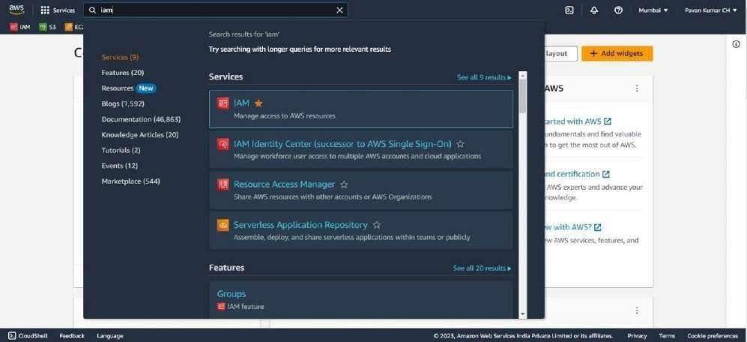

Step 2: In the IAM dashboard, click on "Users" in the left navigation pane. A list of already existing users will be displayed. click on the "Add user" button to create a new IAM user.

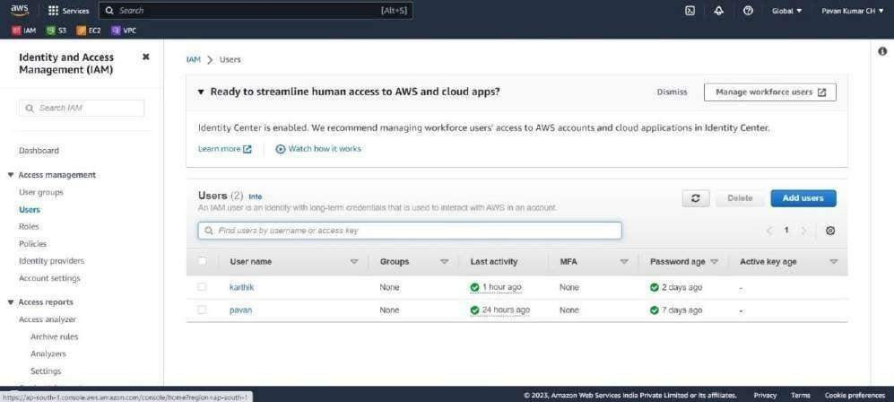

Step 3: On the Specify user details page, under User details, in User name, enter the name for the new user. This is their sign-in name for AWS

Select “Provide user access to the – AWS Management Console”. This produces AWS Management Console sign-in credentials for the new user.

You are asked whether you are providing console access to a person. Select “I want to create an IAM user”.

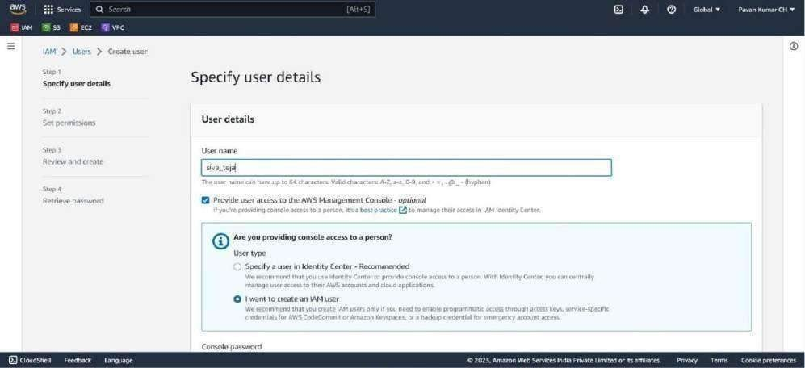

Step 4: For Console password, select “Autogenerated password” and “Users must create a new password at next sign-in”. Click on next

* Autogenerated password – The user gets a randomly generated password that meets the account password policy. You can view or download the password when you get to the Retrieve password page.
* Custom password – The user is assigned the password that you enter in the box.

Step 5: On the Set permissions page, specify how you want to assign permissions for this user. Select “Attach policies directly” option to see a list of the AWS managed and customer managed policies in your account.

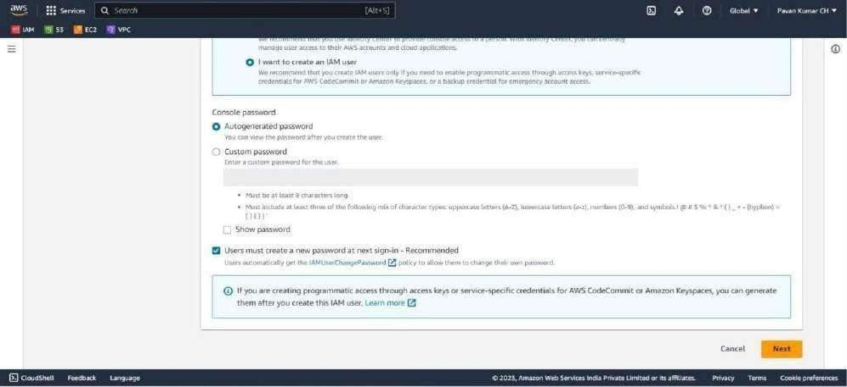

Add user to group – Select this option if you want to assign the user to one or more groups that already have permissions policies.

Copy permissions – Select this option to copy all the permissions from an existing user to the new user.

Step 6: In the search bar, search for “AmazonEC2FullAccess” policy and select the policy to attachit to the user.

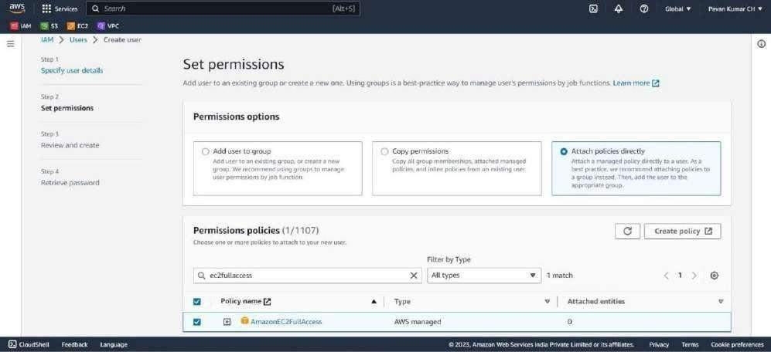

Step 7: In the search bar, search for “CloudFrontFullAcess” policy and select the policy to attach it to

the user.

Click on next button

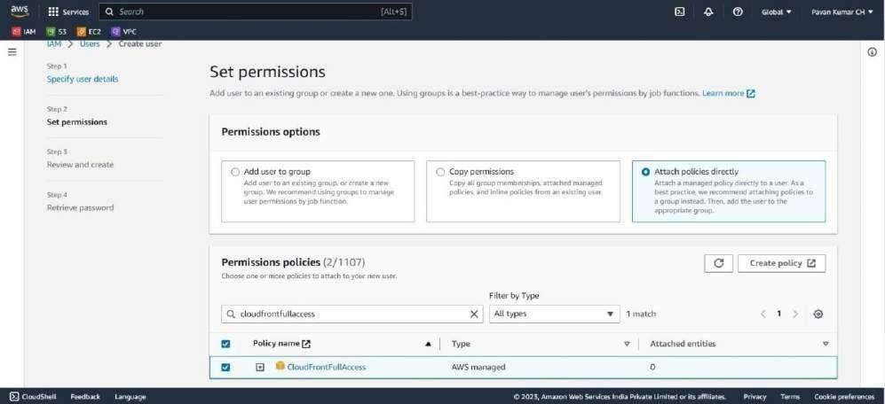

If you want to create a policy, select Create policy button to open a new browser tab and create a new policy.

Step 8: review the permissions summary and ensure that the selected policies are included. Click on the "Create user" button to create the IAM user.

Review all of the choices you made up to this point. When you are ready to proceed, select Create user.

Step 9: On the Retrieve password page, get the password assigned to the user:

* Select Show next to the password to view the user's password so that you can record it manually.
* Select Download .csv to download the user's sign in credentials as a .csv file that you can save to a safe location.

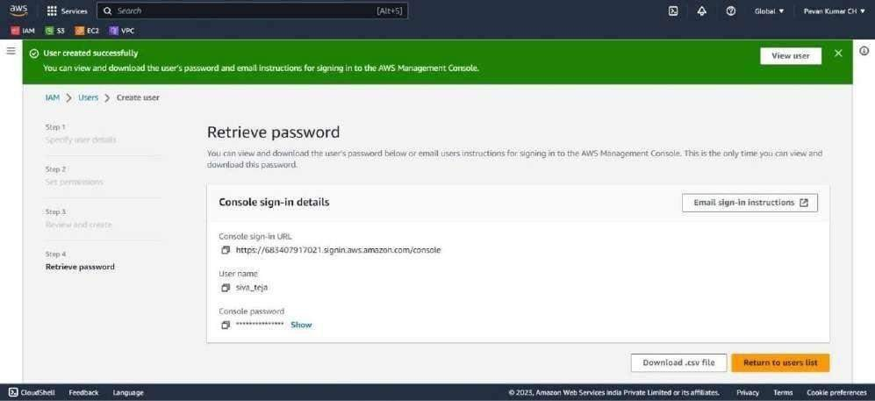

Launching EC2 instance in two different AZs and Configuring web server in the instance

###### EC2 Instance:

Amazon Elastic Compute Cloud (Amazon EC2) is a web service provided by Amazon Web Services (AWS) that allows users to rent virtual servers in the cloud, known as EC2 instances. EC2 instances are the fundamental building blocks of scalable, flexible, and customizable computing resources in AWS.

###### Launching EC2 Instances:

Step 1: Go to the AWS Management Console (h ps://aws.amazon.com/), and sign in using your credentials. Once you're logged in search for the EC2 service.

Step 2: On the EC2 dashboard,click on the “launch an instance” button to initiate instance creation process.

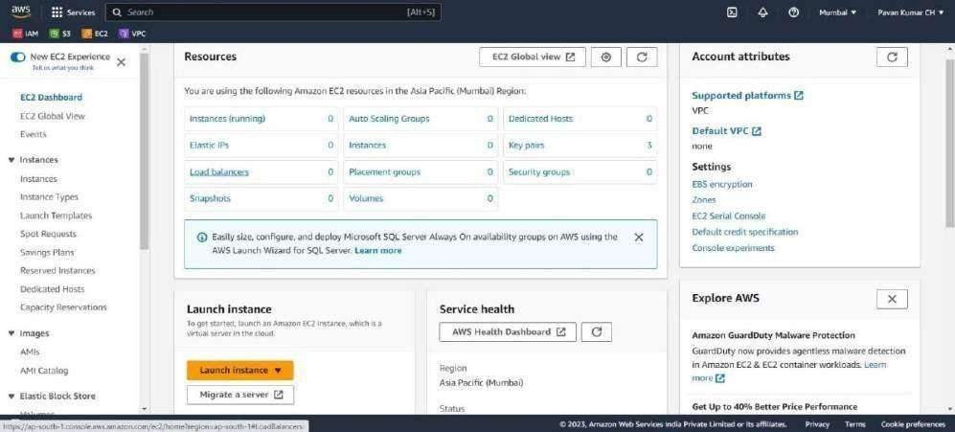

Step 3: Give name for the EC2 Instance.

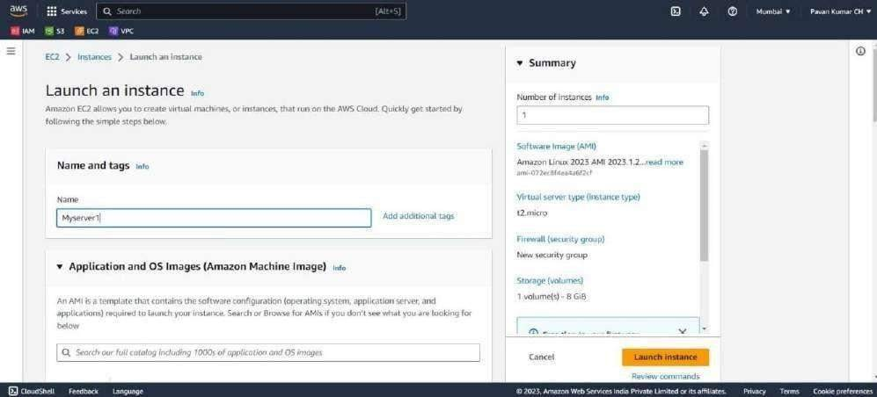

Step 4: Select the desired AMI for your EC2 instance. AMIs are pre-configured templates containing an operating system, software, and other configurations.

Choose Quick Start, and then choose Amazon Linux. This is the operating system (OS) for your instance.

From Amazon Machine Image (AMI), select Amazon Linux 2023 AMI. Notice that these AMIs are marked Free tier eligible.

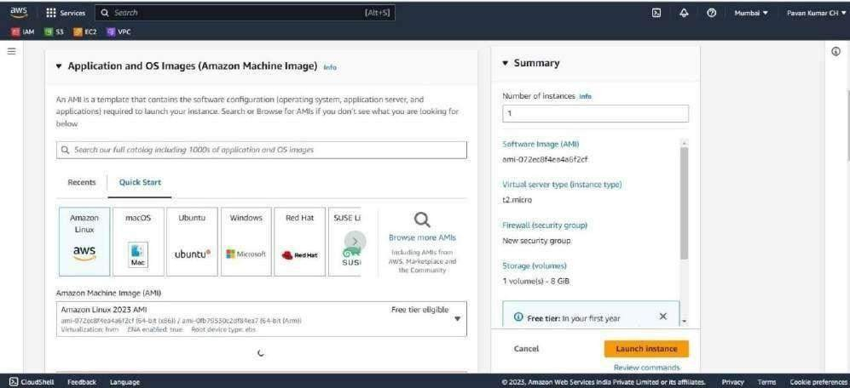

Step 5: Select the instance type that meets your requirements in terms of CPU, memory, storage, and other specifications. You'll be prompted to choose an existing key pair or create a new one. This key pair allows you to connect securely to your instance using SSH.

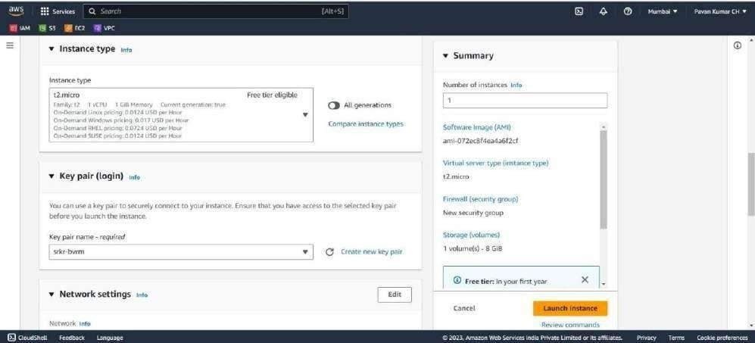

Step 6: Create a security group. Security groups act as virtual firewalls, controlling inbound and outbound traffic to your instance. Configure the necessary rules to allow access to your instance. Select “Allow HTTPS traffic from the internet” and “Allow HTTP traffic from the internet”.

Enabling HTTP traffic (HTTP port 80) to access the website hosted on an EC2 instance is necessary to allow users to visit the website using their web browsers. When you enable HTTP traffic, you are essentially opening port 80 on the EC2 instance, which allows incoming HTTP requests from the internet.

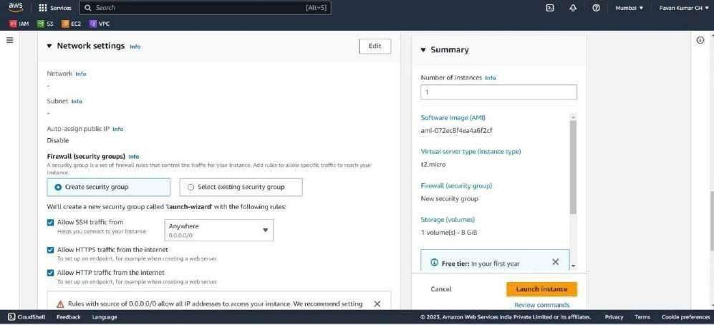

Step 7: Click on edit in network settings

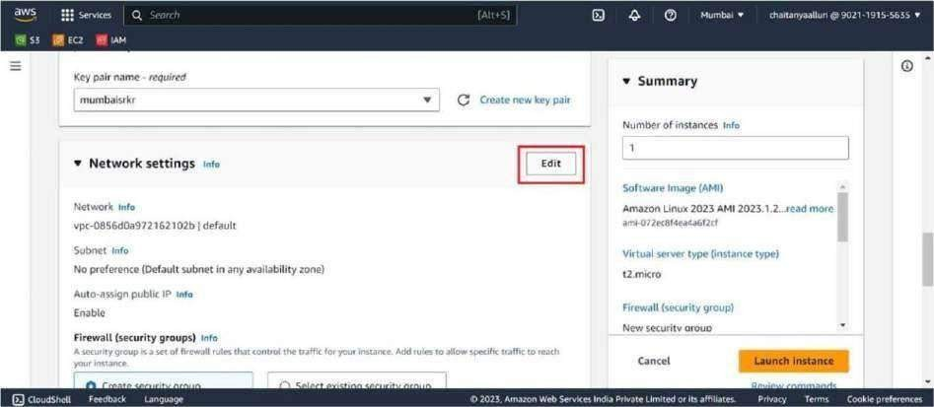

Step 8: you need to select the subnet in which the EC2 instance will reside. Click on Launch Instance Make sure to select subnet present in the different availability zone while creating the second instance.

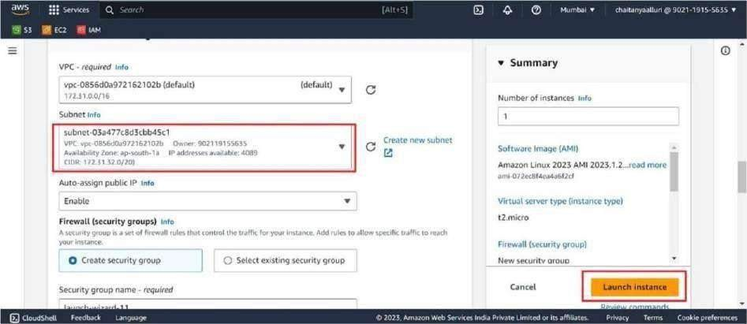

Similarly by following the above steps launch the second Ec2 Instance in another availability zone. To launch an EC2 instance in a particular availability zone we have to select the subnet present in the respective availability zone in network settings.

###### Web Server:

A web server is a software application or a computer system that delivers web content over the internet in response to client requests. It plays a central role in the World Wide Web by hosting websites and serving web pages to users' web browsers.

When a user enters a URL (Uniform Resource Locator) or clicks on a hyperlink in their web browser, the browser sends a request to the web server associated with that URL. The web server processes the request and sends back the requested web page or web content, which is displayed in the user's browser.

###### Configuring web Server:

Step 1: In the EC2 dashboard, locate your running instance and select it. Click on the "Connect" button at the top of the page.

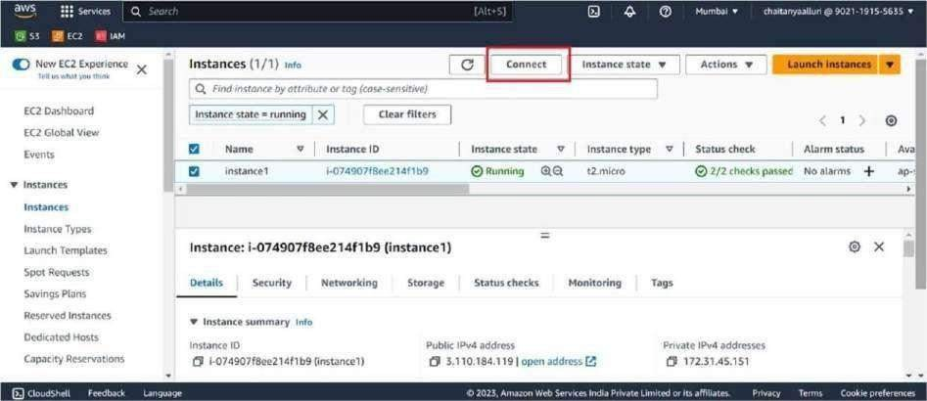

Step 2: Select the "EC2 Instance Connect" option from the "Connect" menu and click "Connect."

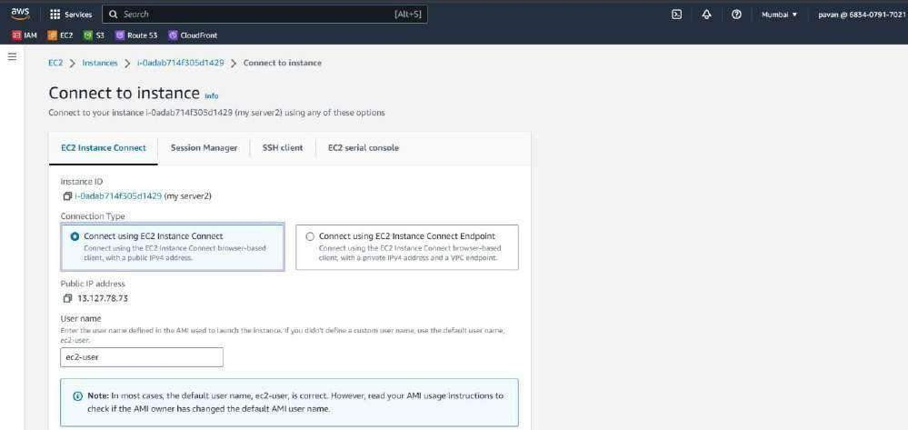

Step 3: A new browser-based SSH session will open, and you will be automatically connected to your EC2 instance using Instance Connect.

You should see the command prompt of your EC2 instance in the browser, indicating that you have successfully connected.

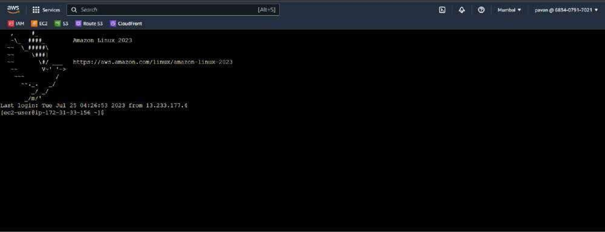

Step 4: Enter the following commands to install the Apache web server.

1. Sudo su: To switch to the superuser (root) account.
2. Yum update -y: It is used to update all installed packages on the system to their latest available versions without user interaction.
3. Yum install httpd: It is used to install the Apache HTTP Server (often simply referred to as "Apache") on Linux distributions.

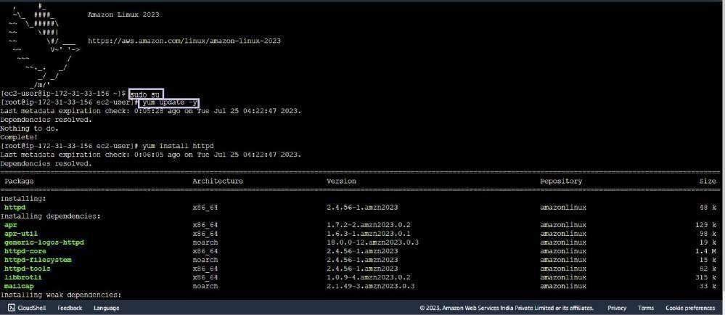

The Apache HTTP Server is one of the most widely used web servers globally. It is an opensource and powerful web server software that can host websites, serve web content, and process HTTP requests from clients (such as web browsers).

Step 5: Start the Apache service and enable it to start automatically on boot. The commands are 1.Systemctl enable httpd: It is used to enable the Apache HTTP Server (httpd) service to start

automatically at system boot on Linux distributions.

1. Systemctl start httpd: It is used to manually start the Apache HTTP Server (httpd) service.

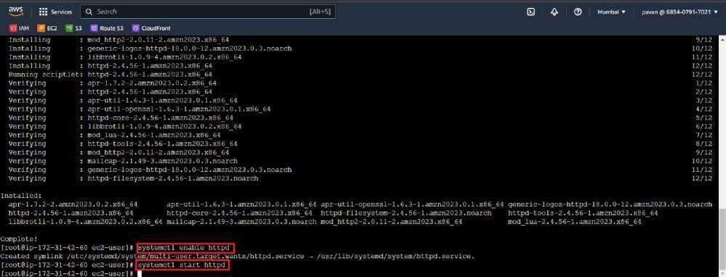

Step 1: create template zip file on EC2 instance. To download files from the web to your local machine or server we use wget command.

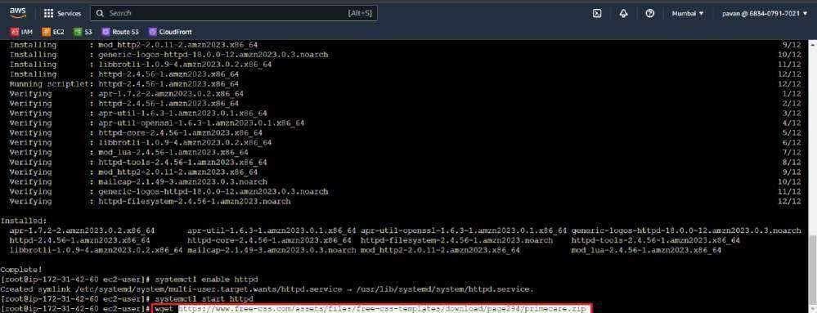

Step 3: we have to unzip the downloaded file. To unzip we use ‘unzip’ command.

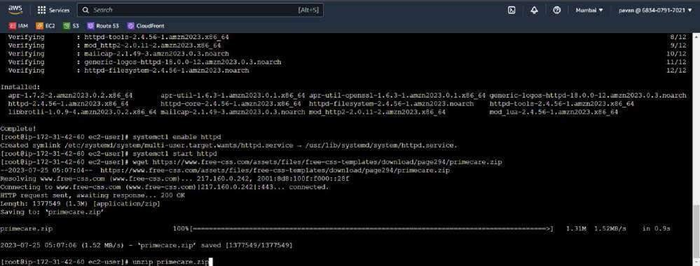

After unzipping process is completed a new folder will be created and all the template files are placed in it. To know the name of that folder we use ls command

Ls: It is used to list the contents of a directory.

Step 4: Move the extracted template files to the Apache document root directory. The web server needs to know where to find the files that make up your website. By default, the web server's "Document Root"

directory is the location where it looks for website files. The document root is typically located at

/var/www/html/. Use the following commands to move the files.

* 1. ls: To know the name of folder created after unzipping
  2. cd: To change the directory
  3. mv * /var/www/html/: To move all the template files to rootdirectory.
  4. cd /var/www/html/: To move to root directory.
  5. ls: check for the files.

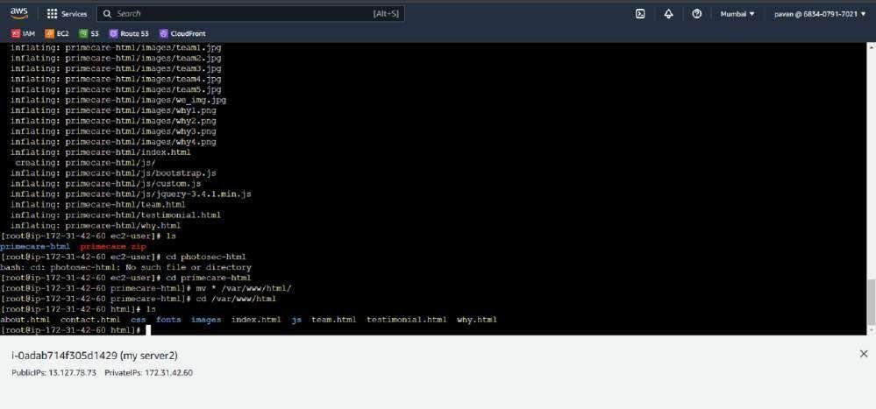

the website files are uploaded and the web server is properly configured, visitors can access your website by entering the public IP address or domain name of your EC2 instance in their web browsers.

###### Access Your Website:

Once the website files are uploaded and the web server is properly configured, visitors can access your website by entering the public IP address or domain name of your EC2 instance in their web browsers.

Ensure that your EC2 instance has a security group configured to allow inbound traffic on the necessary ports (e.g., port 80 for HTTP or port 443 for HTTPS). If you are using the default security group, it should already allow inbound traffic on port 22 for SSH and port 80 for HTTP.

Step 1: Find the EC2 instance hosting your website and copy its public IP address.

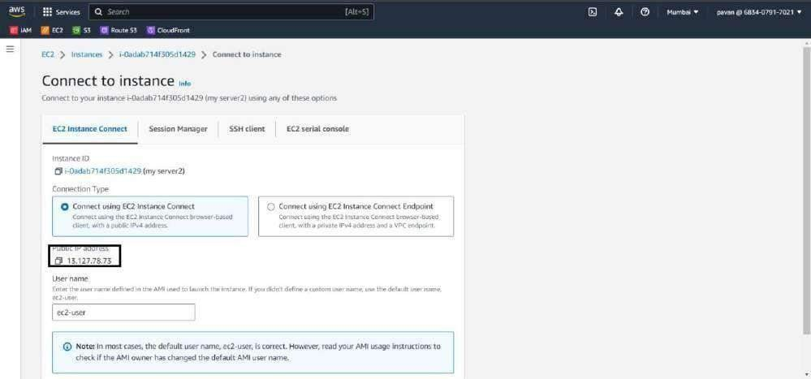

Step 2: Enter the public IP address of your EC2 instance directly into the browser's address bar and press Enter.



Similarly configure the webserver in the second instance and host a different website in it.

Create a Load balancer in the specified region and balance traffic Between two instances

###### LOAD BALANCER:

In AWS (Amazon Web Services), a load balancer is a service that distributes incoming application or network traffic across multiple servers (instances) to ensure that no single server becomes overwhelmed, and that the workload is evenly distributed. The load balancer helps to improve the availability and fault tolerance of your application, as well as enhances its performance and scalability.

Load balancers continuously monitor the health and status of servers in the backend pool. They perform health checks by sending periodic requests to the servers and verifying their responses. If a server fails the health check, the load balancer automatically removes it from the pool, directing traffic only to healthy servers. Target Group:

A target group is a logical group of targets (instances or services) that the load balancer routes requests to. When you set up an application load balancer or network load balancer, you create one or more target groups, and each target group is associated with a specific set of ports on the instances.

Crea ng a Target Group:

After creating two instances in two different availability zones follow the below stated steps to create a target group.

Step-1: In EC2 dashboard click on “Target groups” in the left navigation pane.

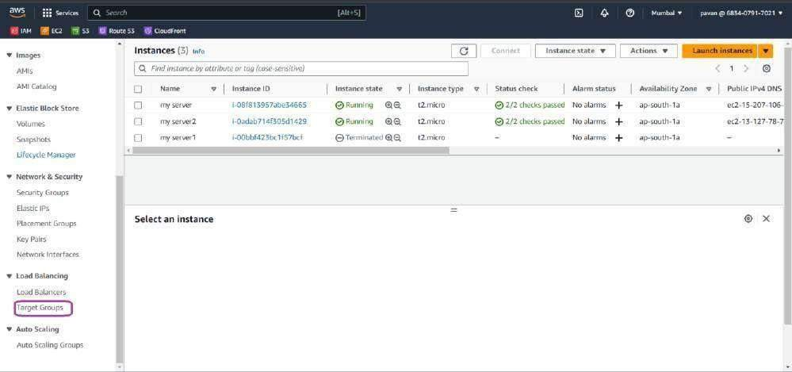

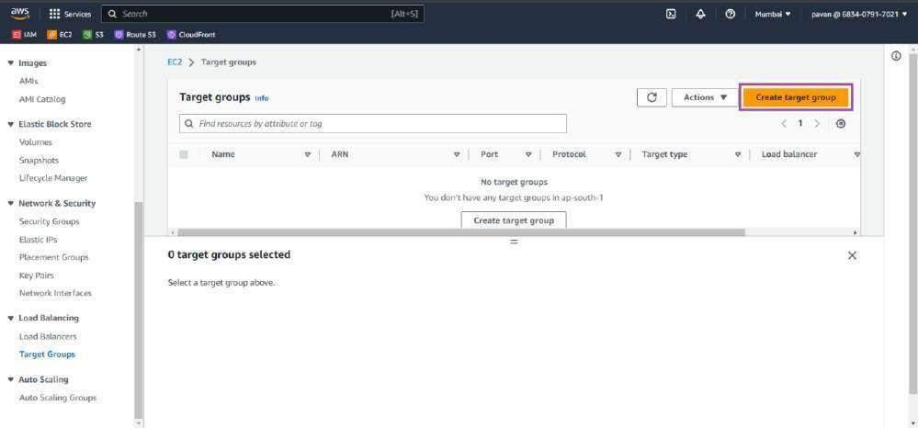Step-2: click on “Create target group”

Step-3: In the Basic configuration choose the Target type as “Instance” since we are going to be working using instances.

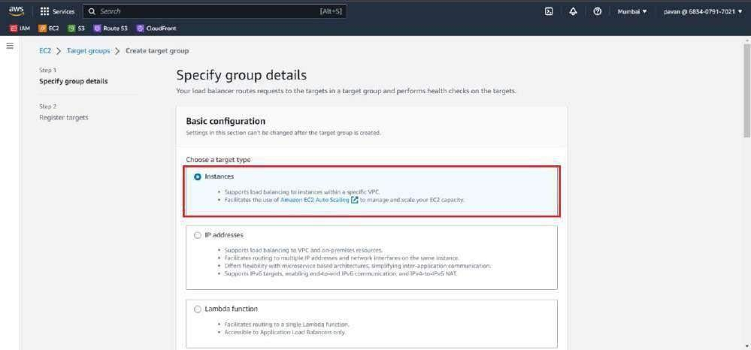

We can choose IP addresses to register targets by IP address, or Application Load Balancer to register an Application Load Balancer as a target.

Step-4: Give the Target Group a name.

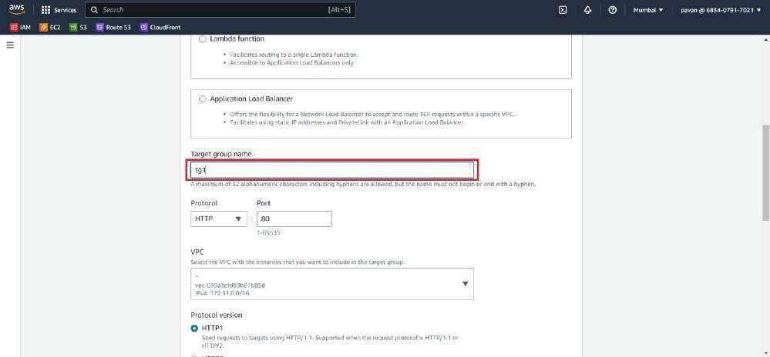

Step-5: Click on “Next”.

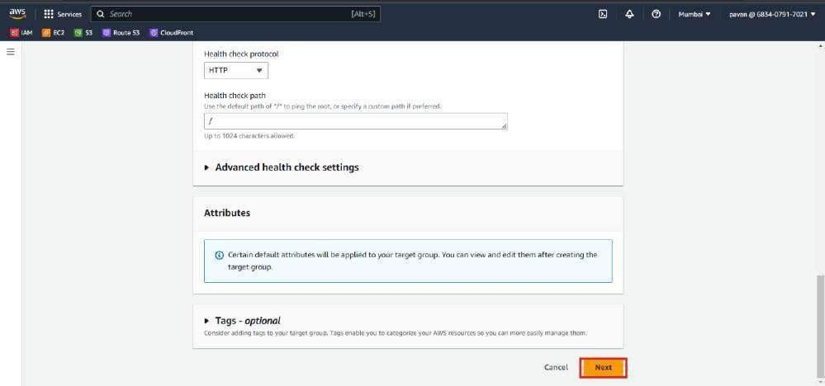.

Step-6: Select the two available instances.

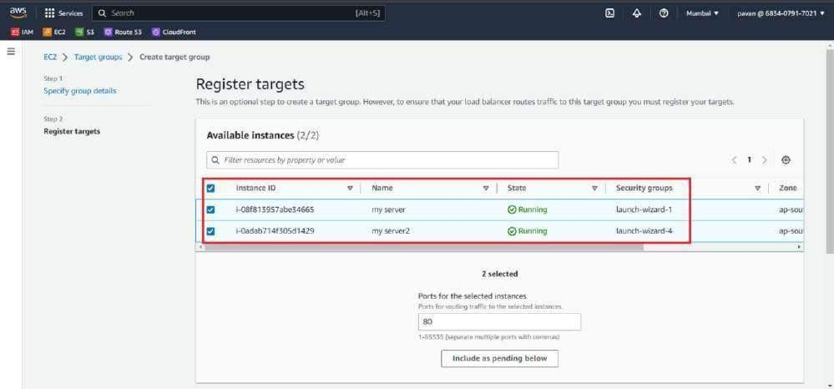

Step-7: Click on “Include as pending”.

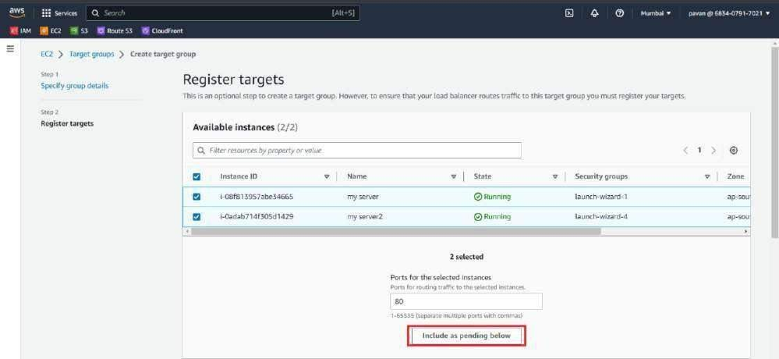

Step-8: Click on “Create Target group”.

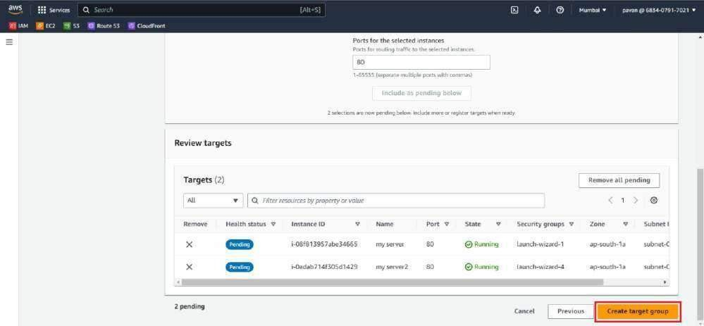

Target group is successfully created. Now we need to associate the target group with a load balancer and register the desired resources (instances, IP addresses, or Lambda functions) with the target group. This allows the load balancer to start directing traffic to the registered resources based on the defined routing rules and health checks.

Crea ng an Elas c Load Balancer:

Follow the below stated steps to create an elastic load balancer to balance the traffic between two instances.

Step-1: In EC2 dashboard click on “Load balancers” in the left navigation pane and click on “Create

Load balancer” button.

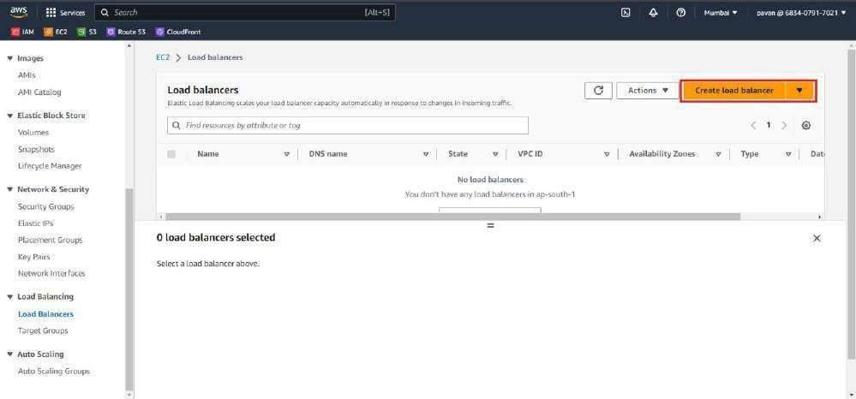

Step-2: Select the appropriate load balancer type based on your requirements. AWS offers Application Load Balancer (ALB) for HTTP/HTTPS traffic or Network Load Balancer (NLB) for TCP/UDP traffic.

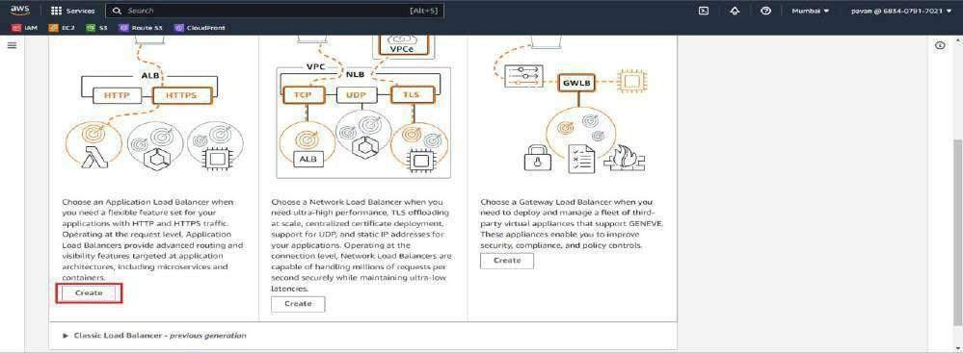Click on “Create” in the Application Load balancer section.

Step-3: In the Basic Configuration section, choose a name for the Load balancer.

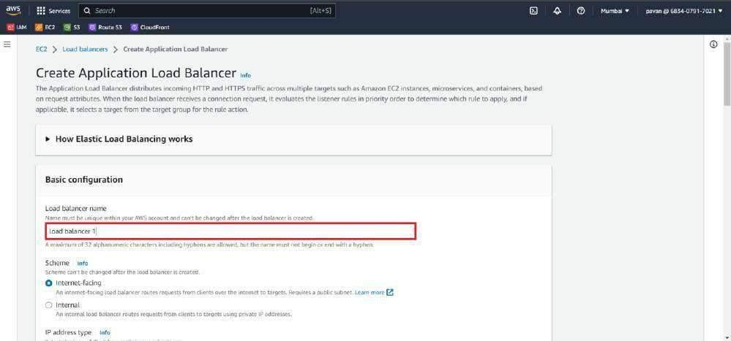

Step-4: In the Mapping section select the availability regions in which your Instances are present. This automatically selects a subnet for those selected availability regions. Or we can select all the availability regions in case of Autoscaling.

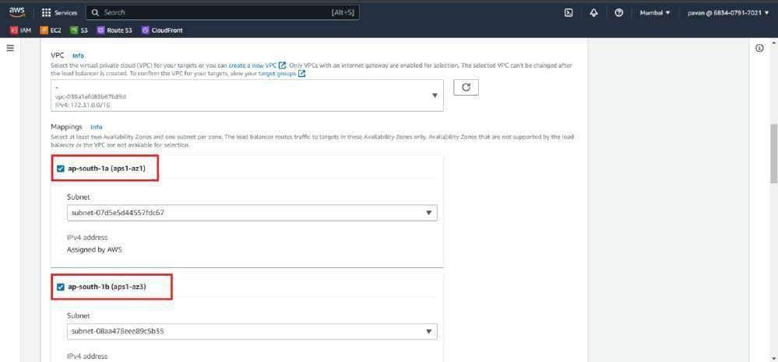

Step-5: In Listeners and routing section go to default action and select the target group which was previously created.

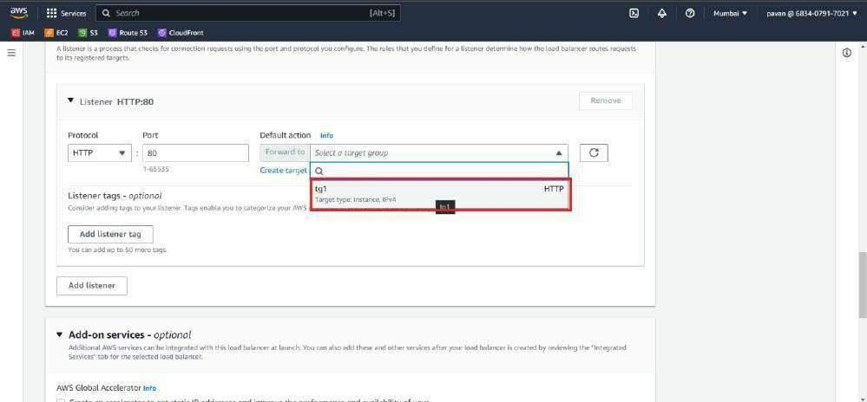

Step-6: Click on “Create Load balancer”.

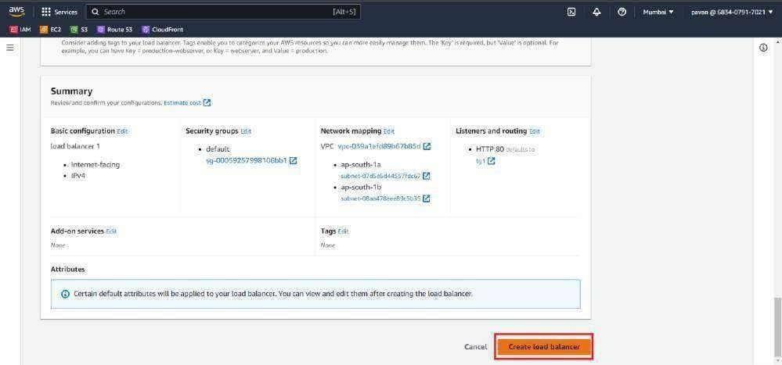

Step-7: The page refreshes and displays that the Load balancer is created. To view the Load balancer, click on “View Load balancer” button.

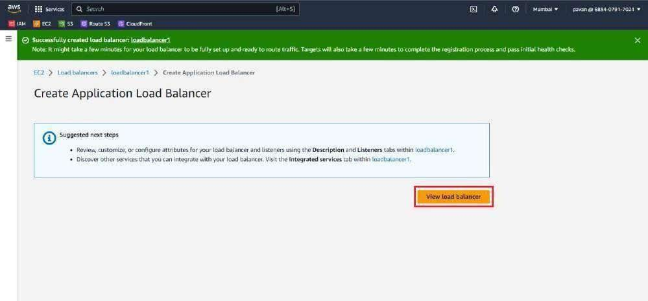

# Verifying the load balancer DNS on the browser

Load balancers are designed to distribute traffic across multiple backend servers. By checking the load balancer's DNS, you ensure that it is correctly distributing traffic among the healthy servers,

providing high availability and redundancy.

Load balancers evenly distribute incoming requests among backend servers based on defined algorithms. Verifying the DNS helps you confirm that the load balancer is performing this function correctly, preventing any single server from being overwhelmed with traffic. Verifying the Load balancer DNS:

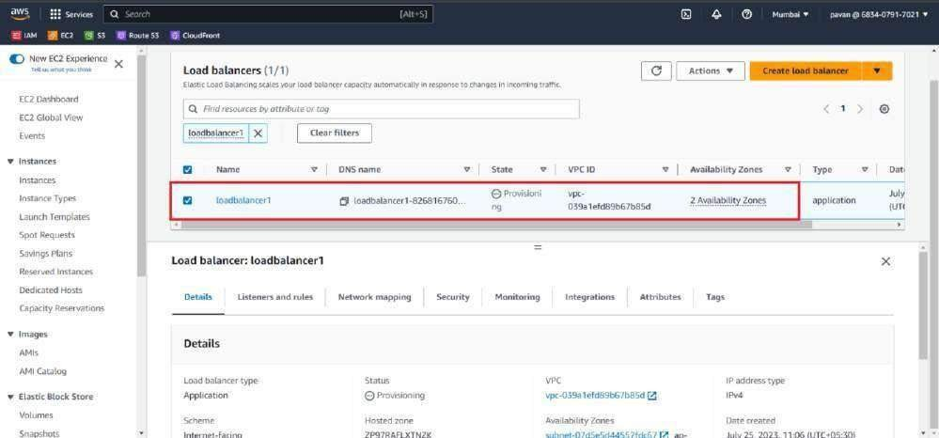By following the below steps, you can verify the load balancer's DNS configuration and ensure that it is functioning correctly to distribute traffic to your application or website. Step 1: Select the Load balancer

Step 2: Copy the DNS Name of the selected load balancer.

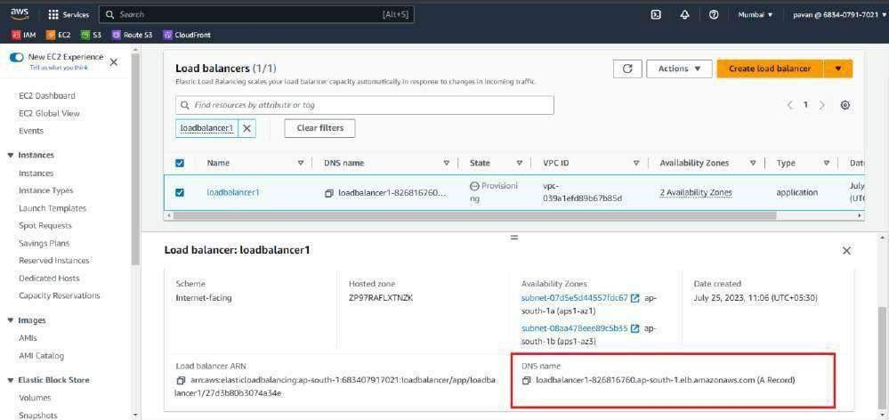

Step 3: paste the DNS name of the load balancer on the browser. One of the hosted websites should be displayed on the browser.

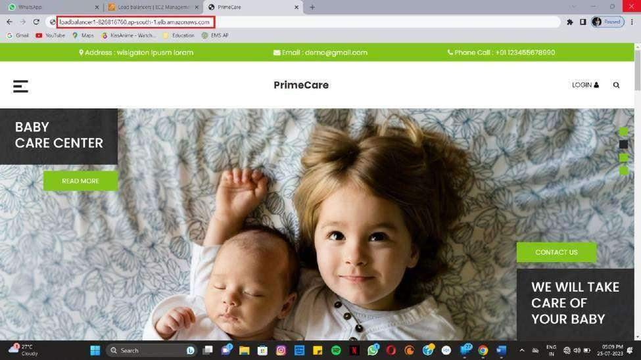

### Create a cloud front distribution and

### push the load balancer DNS to the cloud front

Cloud front:

In AWS (Amazon Web Services), Amazon CloudFront is a content delivery network (CDN) service that securely delivers data, videos, applications, and APIs to customers globally with low-latency, high-speed transfers. It is designed to provide a scalable and efficient way to distribute content to users, reducing latency and improving the overall user experience.

By using CloudFront, you can effectively offload traffic from your origin server, reduce is commonly used for serving static and dynamic content, live or on-demand streaming of media files, and improving website performance.

##### Steps to create cloud front distribution:

**Step 1**: go to the AWS Management Console and navigate to the "CloudFront" service.

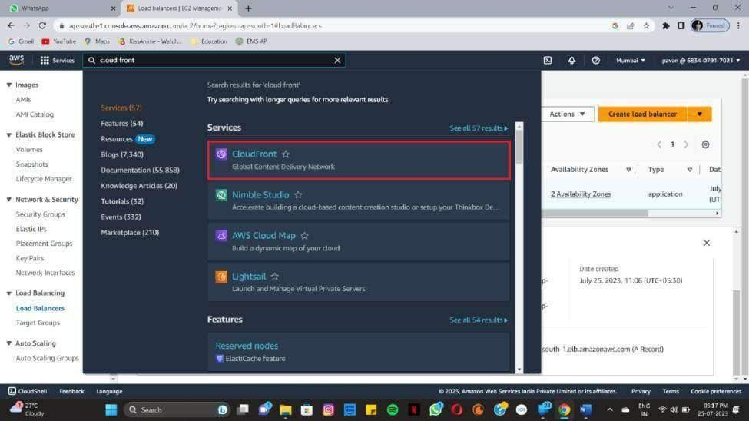

Step2: Select create distribution

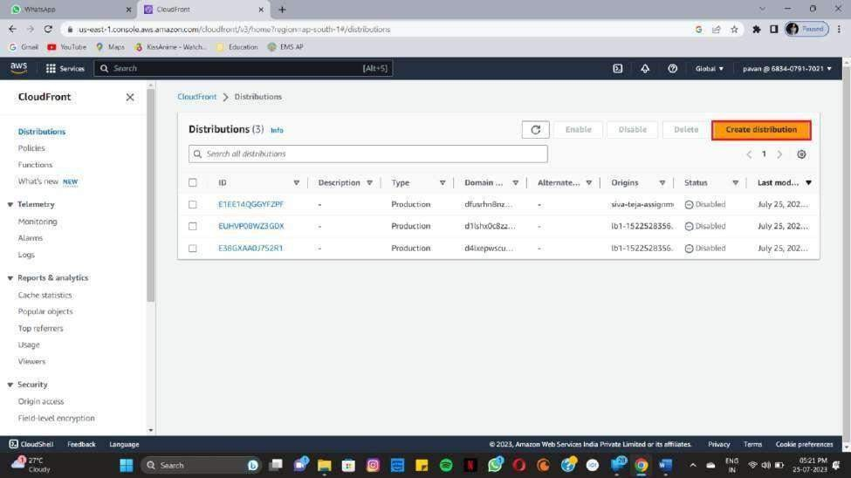

**Step3:**In the distribution creation wizard,choose the “Web” delivery method,which is used for delivering content over HTTP and HTTPS.

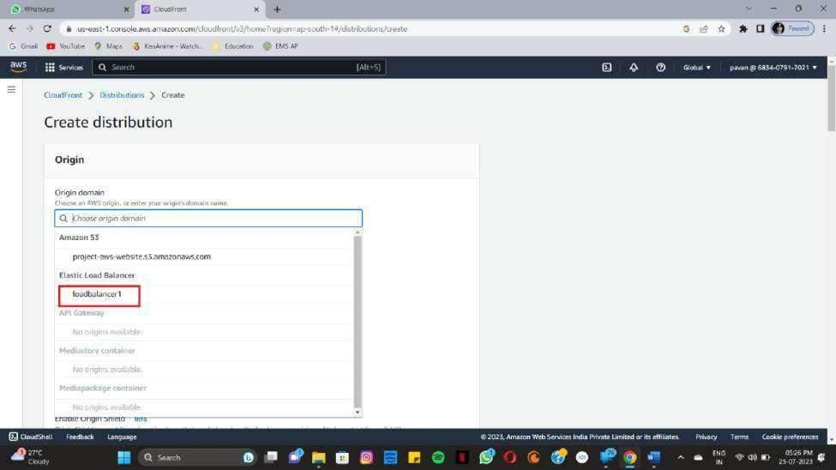

**Step4:**under the cache key and origin requests section choose legacy cache settings under select all.

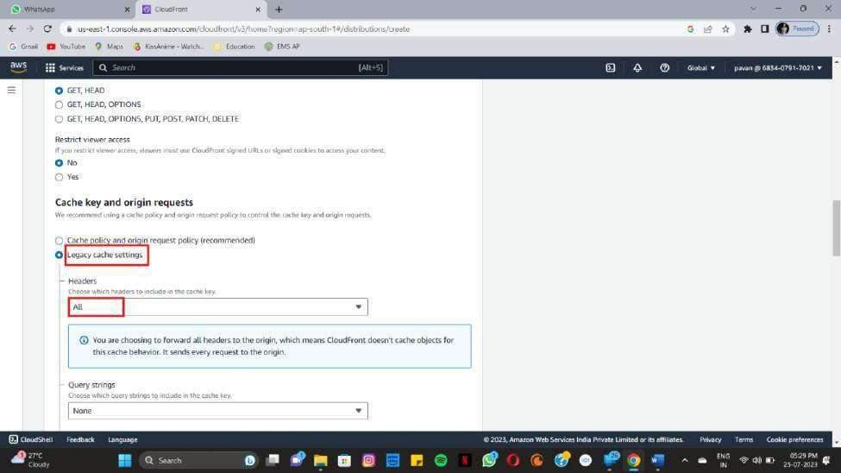

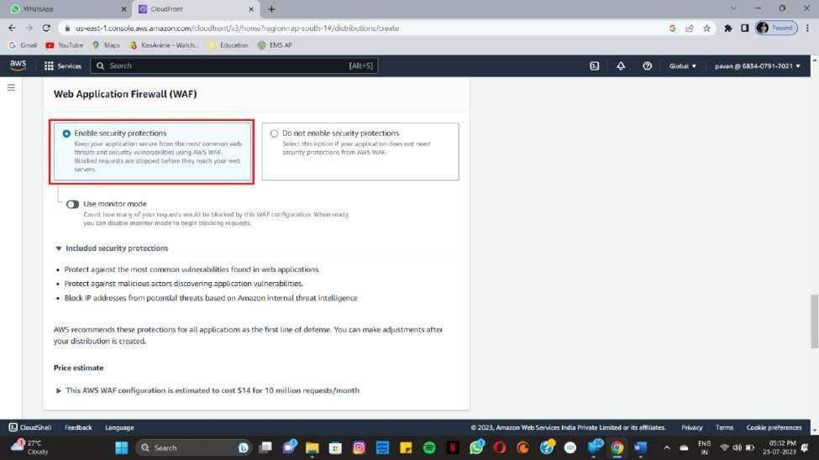**Step 5**:Enable web application fire wall.

**Step6:**Click on create distribution.

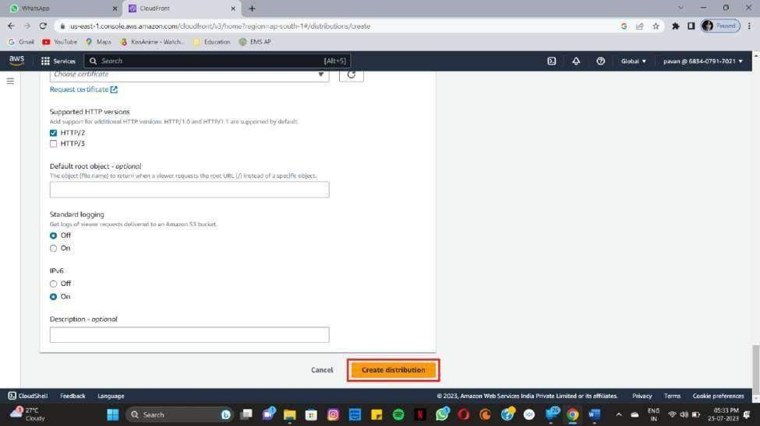

**Step 7:**When your distribution is deployed,confirm that you can access your content using your cloud front domain name. copy the domain name

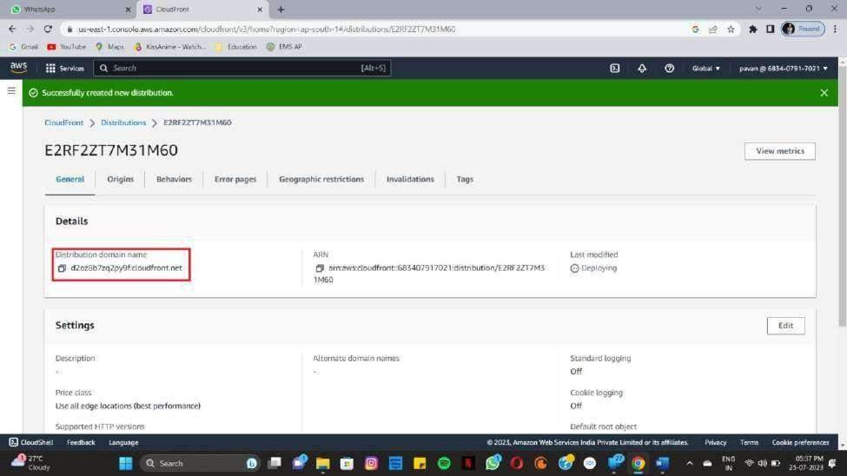

**Step7:**paste it on the browser.

